SUTTON BENGER PARISH COUNCIL

A GENERAL MEETING OF THE COUNCIL to be held in the Village Hall on
Wednesday 12 March 2013 at 19.45

All Members of the Council are summoned to attend for the purpose of considering and resolving upon the business to be transacted at the meeting as set out below.

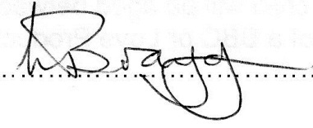
Linda Bragg
Clerk to the Parish Council
AGENDA

- Members of the public are invited to address the Council

- To receive apologies for absence from the meeting

- Chair’s Announcements

- To receive declarations of personal or prejudicial interests in matters under consideration

- To approve the minutes of the Meeting of the Parish Council 12th February 2014

- Summary of the main items of importance from correspondence - Clerk

- Planning and Development Control
To review open planning applications and agree responses:

14/01753/TCA | 25 High Street, Sutton Benger, SN15 4RQ | 20% Crown reduction to 4 Birch and 1 Eucalyptus Trees
14/01542/FUL | 10 Sutton Lane, Langley Burrell, SN15 4LW | Two Storey Side Extension

- Highways and Transport

- Emergency Planning/Flooding

- Police Liaison/Neighbourhood Watch

- Chippenham Area Board

- To approve fee of £120 payable by Sutton Benger Allotment Gardens Association

- To approve expenditure of up to £80 for the Internal Auditor

- Agreement to read and consider any amendments to the Financial Regulations

- Annual Parish Meeting topics: Emergency Planning, Community Fund Allocation and any other suggestions.

- To approve invoices list available from the Clerk

- To go through Clerk’s Report

The next meeting is the Annual Parish Meeting scheduled for Wednesday 9th April 2014 in the Village Hall, starting at 7.45 pm. The Annual Meeting of the Parish Council will be held on Wednesday 14th May 2014 in the Village Hall.

